VPC

-          Attached IGW

-          Attached route table

-          DHCP

-          VPG

Subnet

-          Route table

-          NCL

-          AZ

-          VPC

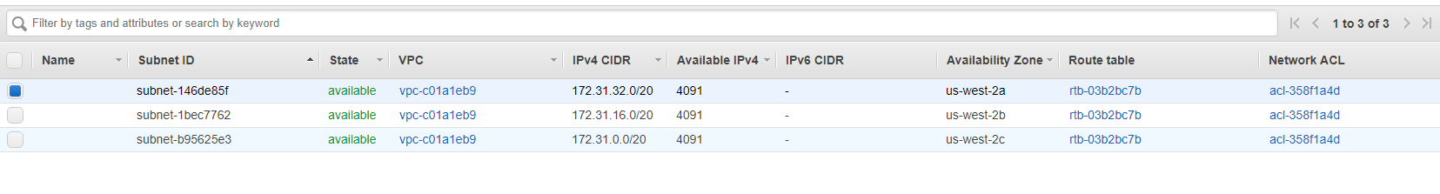

Public IP v/s Elastic IP

Elastic IP is associated with ur account , public IP not

EIP Doesn't change after stop/start.

You cannot manually associate or disassociate a public IP address

**From:** Shantaram Vernekar <shantaram_vernekar@persistent.com>   
**Sent:** Wednesday, July 11, 2018 1:27 PM  
**To:** Shantaram Vernekar <shantaram_vernekar@persistent.com>; Vernekar, Shantaram [CCC-OT NE] <sv16217@imcnam.ssmb.com>  
**Subject:** AWS - VPC

**VPC**

**-------**

**Default VPC**

**Public facing subnet (Internet access) – Web Servers**

**Private facing subnet (No internet access) – Application servers and databases**

**Security Group & Network ACL – control access to EC2 instances**

**Corporate Datacenter < -------- VPN ------- >  VPC cloud in AWS**

**In a region → Multiple VPC can be created, each will be logically isolated**

**Two VPC in a region → each can share the IP address space..**

**To allow peering → VPC cannot share address space.. or overlapping..**

**When creating VPC -> IP address range needs to be specified**

**Once created cannot be changed**

EC2-Classic and EC2-VPC.

-          single, flat network shared with other AWS customers called EC2-Classic.

AWS accounts created after December 2013 only support launching instances using EC2- VPC.

**Previous account – both –**

default VPC created in each region with a default subnet created in each Availability Zone. The assigned CIDR block of the VPC will be [172.31.0.0/16](https://urldefense.proofpoint.com/v2/url?u=http-3A__172.31.0.0_16&d=DwQFAg&c=j-EkbjBYwkAB4f8ZbVn1Fw&r=e6HgaTz-VmlyFzQ6g-ctUAxWf7XUSNXlQ5y-qpblsjA&m=XfaPU__el0Xyah6EN7I0EEOJWre3PC1LZWIr3r-C6G8&s=oe-URvWKcm7hk_MpqIhX3hwqCdOvmeU4Q86jj4xeWM4&e=).

An Amazon VPC consists of the following components:

-          Subnets

-          Route tables

-          Dynamic Host Configuration Protocol (DHCP) option sets

-          Security groups

-          Network Access Control Lists (ACLs)

An Amazon VPC has the following optional components:

-          Internet Gateways (IGWs)

-          Elastic IP (EIP) addresses

-          Elastic Network Interfaces (ENIs)

-          VPC Endpoints

-          VPC Peering

-          Network Address Translation (NATs) instances and NAT gateways

-          Virtual Private Gateway (VPG), Customer Gateways (CGWs), and Virtual Private Networks (VPNs)

Subnet

A *subnet*is a segment of an Amazon VPC’s IP address range where you can launch Amazon EC2 instances, Amazon Relational Database Service (Amazon RDS) databases, and other AWS resources

[**10.0.0.0/16**](https://urldefense.proofpoint.com/v2/url?u=http-3A__10.0.0.0_16&d=DwQFAg&c=j-EkbjBYwkAB4f8ZbVn1Fw&r=e6HgaTz-VmlyFzQ6g-ctUAxWf7XUSNXlQ5y-qpblsjA&m=XfaPU__el0Xyah6EN7I0EEOJWre3PC1LZWIr3r-C6G8&s=d3BFtwZAwVT8AnkilgxMVvuepDzrVg51ZQhPR2dR2BQ&e=)**-**[**10.0.0.0/28**](https://urldefense.proofpoint.com/v2/url?u=http-3A__10.0.0.0_28&d=DwQFAg&c=j-EkbjBYwkAB4f8ZbVn1Fw&r=e6HgaTz-VmlyFzQ6g-ctUAxWf7XUSNXlQ5y-qpblsjA&m=XfaPU__el0Xyah6EN7I0EEOJWre3PC1LZWIr3r-C6G8&s=JQxsjL5Hmk4I7FTLE-XbHMN1J2LWWZ-OwkgbMIr0kFQ&e=)

[192.168.0.0/24](https://urldefense.proofpoint.com/v2/url?u=http-3A__192.168.0.0_24&d=DwQFAg&c=j-EkbjBYwkAB4f8ZbVn1Fw&r=e6HgaTz-VmlyFzQ6g-ctUAxWf7XUSNXlQ5y-qpblsjA&m=XfaPU__el0Xyah6EN7I0EEOJWre3PC1LZWIr3r-C6G8&s=CFWGdPoiCT7wtYWLlbRXTOPJEDFAznr5ubraprytmEs&e=)

[172.31.0.0/16](https://urldefense.proofpoint.com/v2/url?u=http-3A__172.31.0.0_16&d=DwQFAg&c=j-EkbjBYwkAB4f8ZbVn1Fw&r=e6HgaTz-VmlyFzQ6g-ctUAxWf7XUSNXlQ5y-qpblsjA&m=XfaPU__el0Xyah6EN7I0EEOJWre3PC1LZWIr3r-C6G8&s=oe-URvWKcm7hk_MpqIhX3hwqCdOvmeU4Q86jj4xeWM4&e=)

The smallest subnet that you can create is a /28 (16 IP addresses). AWS reserves the first four IP addresses and the last IP address of every subnet for internal networking purposes.

For example, a subnet defined as a /28 has 16 available IP addresses; subtract the 5 IPs needed by AWS to yield 11 IP addresses for your use within the subnet.

Subnets reside within one Availability Zone and cannot span zones

multiple subnets in one Availability Zone

Subnets can be classified as public, private, or VPN-only.

**Public subnet  ---- Route table ---- Internet gateway**

**Private subnet  ---- Route table ---- Internet gateway**

**VPN Only subnet  ---- Route table ---- Internet gateway**

**---- VPG (Virtual Private gateway)**

VPN-only subnet is one in which the associated route table directs the subnet’s traffic to the Amazon VPC’s VPG (discussed later) and does not have a route to the IGW

Default Amazon VPCs contain one public subnet in every Availability Zone within the region, with a netmask of /20

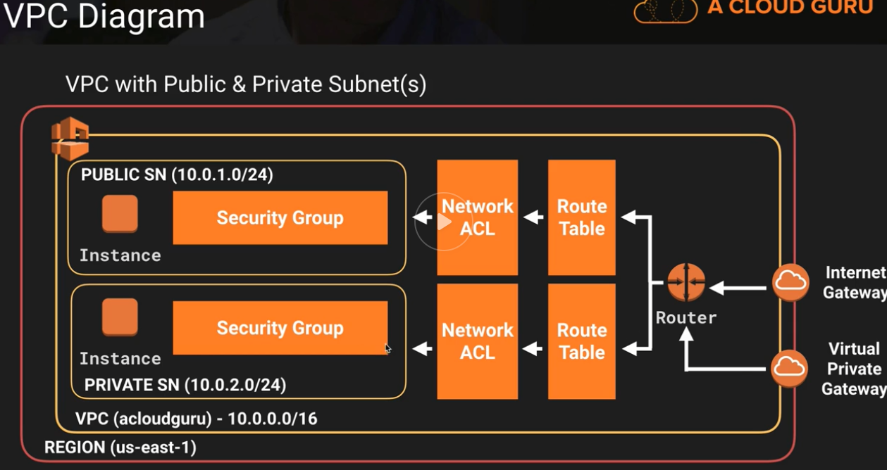

**In a single VPC**

[**10.0.0.0/16**](https://urldefense.proofpoint.com/v2/url?u=http-3A__10.0.0.0_16&d=DwQFAg&c=j-EkbjBYwkAB4f8ZbVn1Fw&r=e6HgaTz-VmlyFzQ6g-ctUAxWf7XUSNXlQ5y-qpblsjA&m=XfaPU__el0Xyah6EN7I0EEOJWre3PC1LZWIr3r-C6G8&s=d3BFtwZAwVT8AnkilgxMVvuepDzrVg51ZQhPR2dR2BQ&e=)**– 65536 (Maximum)**

[**10.0.0.0/28**](https://urldefense.proofpoint.com/v2/url?u=http-3A__10.0.0.0_28&d=DwQFAg&c=j-EkbjBYwkAB4f8ZbVn1Fw&r=e6HgaTz-VmlyFzQ6g-ctUAxWf7XUSNXlQ5y-qpblsjA&m=XfaPU__el0Xyah6EN7I0EEOJWre3PC1LZWIr3r-C6G8&s=JQxsjL5Hmk4I7FTLE-XbHMN1J2LWWZ-OwkgbMIr0kFQ&e=)**– 16 (Minimum)**

**You can have multiple VPC created – defalt 5**

[**http://cidr.xyz/**](https://urldefense.proofpoint.com/v2/url?u=http-3A__cidr.xyz_&d=DwMFAg&c=j-EkbjBYwkAB4f8ZbVn1Fw&r=e6HgaTz-VmlyFzQ6g-ctUAxWf7XUSNXlQ5y-qpblsjA&m=XfaPU__el0Xyah6EN7I0EEOJWre3PC1LZWIr3r-C6G8&s=cdEKCwFCV3NIt06v57BGrGkZK54pXelNlaDEBzwC6rw&e=)

**One internet gateway per VPC**

**Default VPC v/s custom VPC**

**Default VPC**

-          **When an account is created AWS auto creates a VPC, start deploying instances right away**

-          **Internet access is enabled. All subnets in default VPC have a route out to internet**

-          **EC2 instances will have both public and private IP address..**

**custom VPC**

-          **EC2 instances will have private IP address if created in private IP address..**

**Route Tables**

A *route table*is a logical construct within an Amazon VPC that contains a set of rules (called routes) that are applied to the subnet and used to determine where network traffic is directed.

Each route table contains a default route called the local route, which enables communication within the Amazon VPC, and this route cannot be modified or removed

Additional routes can be added to direct traffic to exit the Amazon VPC via the IGW, the VPG, or the NAT instance

Your VPC has an implicit router.

Your VPC automatically comes with a main route table that you can modify.

You can create additional custom route tables for your VPC.

Each subnet must be associated with a route table, which controls the routing for the subnet. If you don’t explicitly associate a subnet with a particular route table, the subnet uses the main route table.

You can replace the main route table with a custom table that you’ve created so that each new subnet is automatically associated with it.

Each route in a table specifies a destination CIDR and a target; for example, traffic destined for [172.16.0.0/12](https://urldefense.proofpoint.com/v2/url?u=http-3A__172.16.0.0_12&d=DwQFAg&c=j-EkbjBYwkAB4f8ZbVn1Fw&r=e6HgaTz-VmlyFzQ6g-ctUAxWf7XUSNXlQ5y-qpblsjA&m=XfaPU__el0Xyah6EN7I0EEOJWre3PC1LZWIr3r-C6G8&s=GpKHPXFj9fC8VdxZSJIyB7TG0cGFDkT-J9PdcMCZr2I&e=) is targeted for the VPG. AWS uses the most specific route that matches the traffic to determine how to route the traffic.

**Internet Gateways**

An *Internet Gateway (IGW)*is a horizontally scaled, redundant, and highly available Amazon VPC component that allows communication between instances in your Amazon VPC and the Internet.

An IGW provides a target in your Amazon VPC route tables for Internet-routable traffic, and it performs network address translation for instances that have been assigned public IP addresses.

maintains the one-to-one map of the instance private IP address and public IP address

You must do the following to create a public subnet with Internet access:

-          Attach an IGW to your Amazon VPC.

-          Create a subnet route table rule to send all non-local traffic ([0.0.0.0/0](https://urldefense.proofpoint.com/v2/url?u=http-3A__0.0.0.0_0&d=DwQFAg&c=j-EkbjBYwkAB4f8ZbVn1Fw&r=e6HgaTz-VmlyFzQ6g-ctUAxWf7XUSNXlQ5y-qpblsjA&m=XfaPU__el0Xyah6EN7I0EEOJWre3PC1LZWIr3r-C6G8&s=9rhUDwR0WoHfX3eNuuHy9bHE1wiEx0oeieH_MPKDHmg&e=)) to the IGW.

-          configure your network ACLs and security group rules to allow relevant traffic to flow to and from your instance.

You must do the following to enable an Amazon EC2 instance to send and receive traffic from the Internet:

-          Assign a public IP address or EIP address.

**Dynamic Host Configuration Protocol (DHCP) Option Sets**

AWS automatically creates and associates a DHCP option set for your Amazon VPC upon creation and sets two options: domain-name-servers (defaulted to AmazonProvidedDNS) and domain-name (defaulted to the domain name for your region)

create a custom DHCP option set and assign it to your Amazon VPC. You can configure the following values within a DHCP option set:

***domain-name-servers***—The IP addresses of up to four domain name servers, separated by commas. The default is AmazonProvidedDNS.

***domain-name***—Specify the desired domain name here (for example, [mycompany.com](https://urldefense.proofpoint.com/v2/url?u=http-3A__mycompany.com&d=DwQFAg&c=j-EkbjBYwkAB4f8ZbVn1Fw&r=e6HgaTz-VmlyFzQ6g-ctUAxWf7XUSNXlQ5y-qpblsjA&m=XfaPU__el0Xyah6EN7I0EEOJWre3PC1LZWIr3r-C6G8&s=Q78WAo2PRFxJav_d1i0lYEmwxdAXKd7Fs9ss6hyr06U&e=)).

***ntp-servers***—The IP addresses of up to four Network Time Protocol (NTP) servers, separated by commas

***netbios-name-servers***—The IP addresses of up to four NetBIOS name servers, separated by commas

***netbios-node-type***—Set this value to 2.

Every Amazon VPC must have only one DHCP option set assigned to it.

**VPC Peering**

networking connection between two Amazon VPCs that enables instances in either Amazon VPC to communicate with each other as if they are within the same network

between your own Amazon VPCs or with an Amazon VPC in another AWS account within a single region

A peering connection is neither a gateway nor an Amazon VPN connection and does not introduce a single point of failure for communication

Peering connections are created through a **request/accept protocol**

            Owner send request to peer (Within account , request identified by vpcid or accounted + vcpid)

            Peer has to accept within 1 week

To enable the flow of traffic between the VPCs using private IP addresses, the owner of each VPC in the VPC peering connection must manually add a route to one or more of their VPC route tables that points to the IP address range of the other VPC (the peer VPC).

VPC may have multiple peering connections

peering is a one-to-one relationship between Amazon VPCs, meaning two Amazon VPCs cannot have two peering agreements between them

do not support transitive routing

Between AWS accounts – supported

Important for exam :

You cannot create a peering connection between Amazon VPCs that have matching or overlapping CIDR blocks.

You cannot create a peering connection between Amazon VPCs in different regions. Now supported. Limited regions support.. Inter-Region VPC Peering is available in AWS US East (N. Virginia), US East (Ohio), US West (Oregon) and EU (Ireland) with support for other regions coming soon.

Amazon VPC peering connections do not support transitive routing.

You cannot have more than one peering connection between the same two Amazon VPCs at the same time.

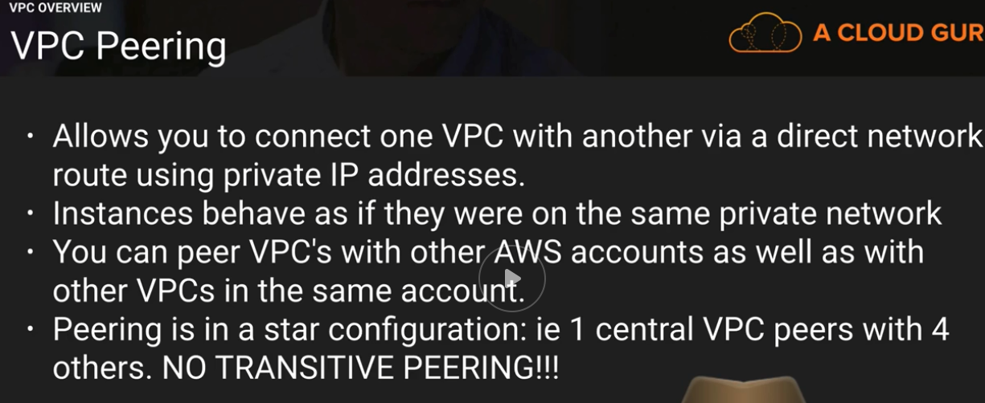

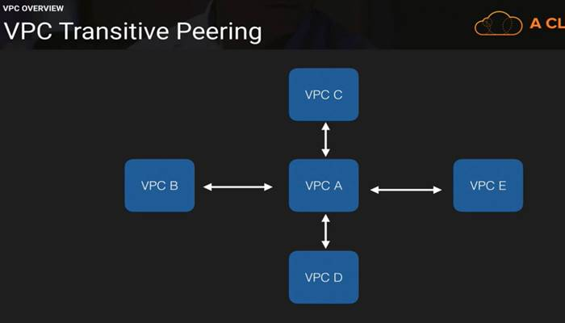

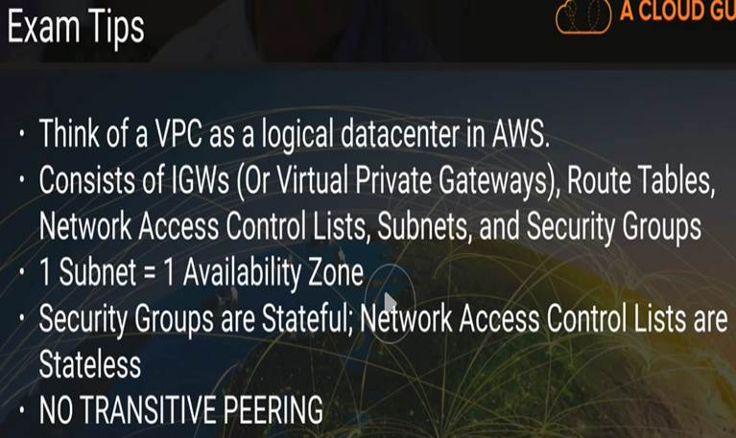

**Create VPC Demo**

-          **Custom VPC**

o   **Creates SG, NACL, Route table**

o   **No subnets**

-          **Create 2 subnets**

-          **Create an internet gateway and attach to VPC**

-          **Enable public IP on one subnet**

-          **Create route table to allow internet**

o   **Add the rule to allow connection to all IPS**

o   **Add the subnet**

o   **Other subnet is on default route that do not allow internet connection.**

-          **Create a WebServer VM in public subnet**

-          **Create a SQL server VM in private subnet**

-          **Connect to WebServer using public IP**

-          **Create a custom SG**

-          **Connect SG to SQL server**

-          **SSH to Web VM**

-          **Ping to SQL**

-          **Try ssh to SQL using private keys..**

**NAT instance**

**Nat Gateways**

**Operates on IPv4**

**Alternate one – Egress only Internet gateways – for IP v6**

**Check out the differences between NAT instance and NAT gateways**

**Both allows interconnectivity for instances in private network -One way**

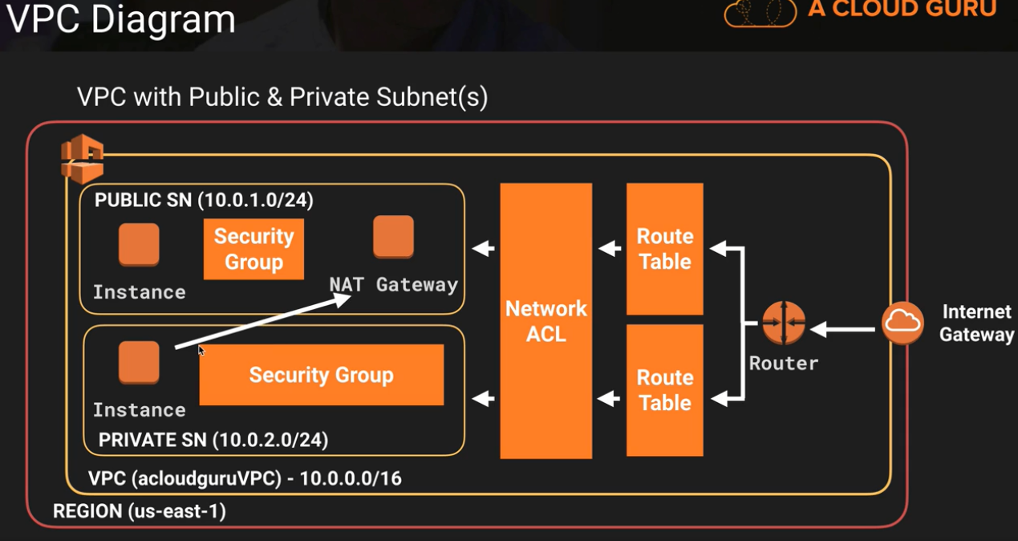

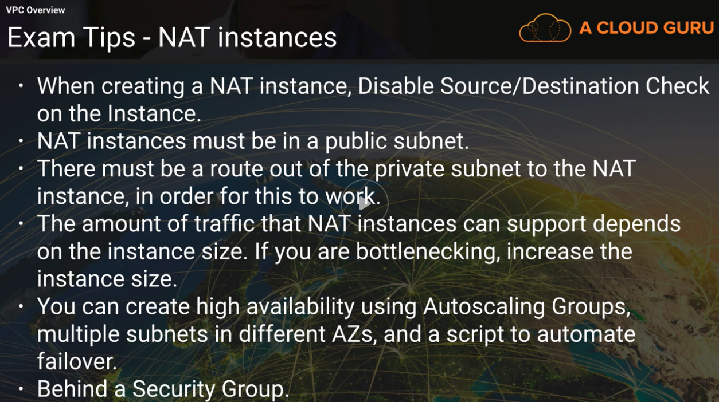

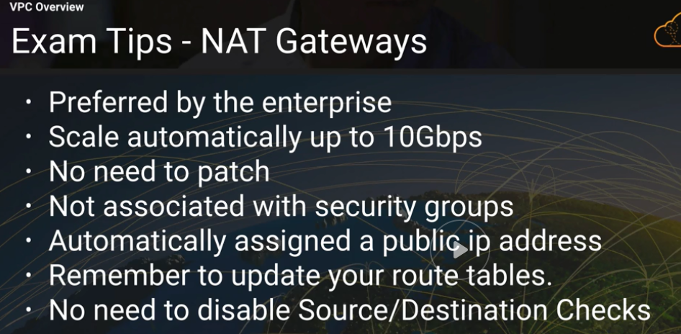

**Network ACL**

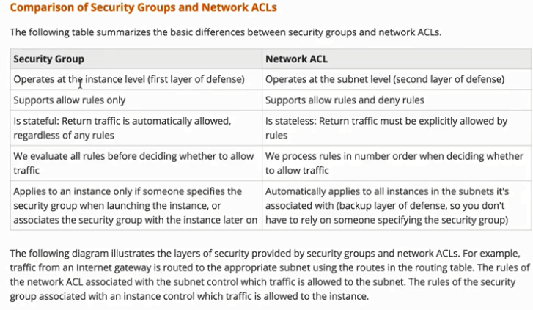

**Subnet X → Can be associated with one ACL at any given time..**

**Subnet X → Can be associated with one Availability zone**

**Custom ACL – default is inbound , outbound is defined**

**Ports that are used by different services.. needs to be opened at NACL as it is stateless..**

**Allow inbound**

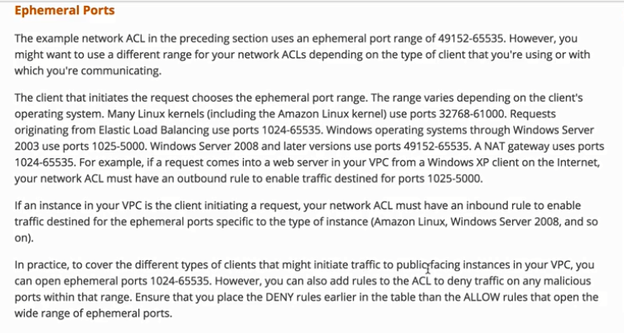

**Rule having a lower rule number takes priority**

**When there are Conflicting rules..**

**NACL provides granular level of security**

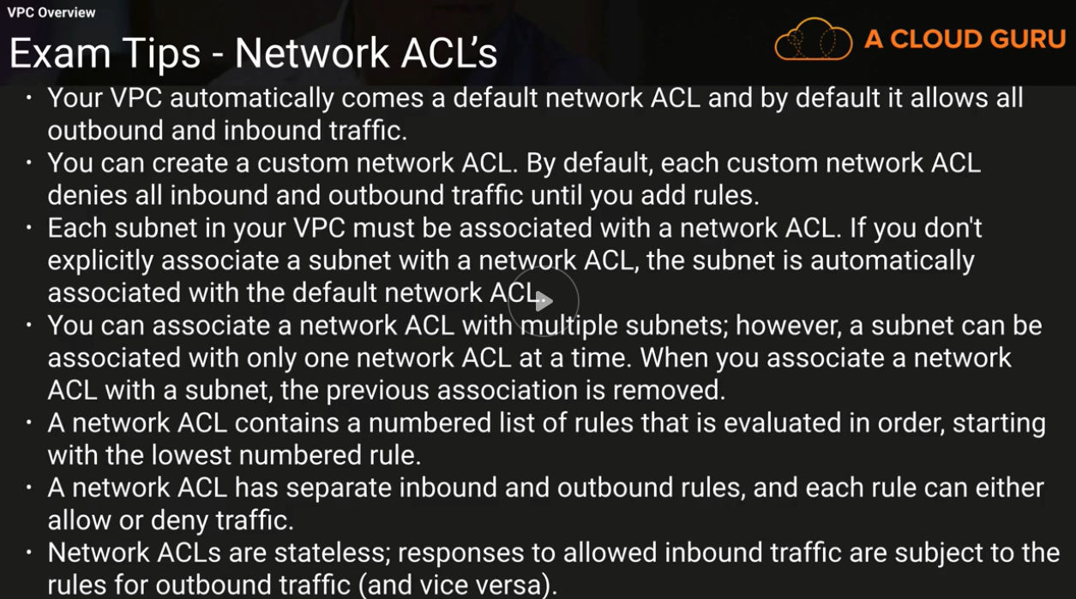

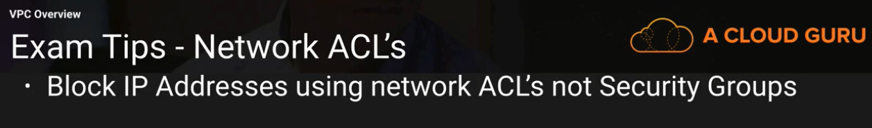

**Application load balancers**

-          **Public facing**

-          **At least 2 subnet public facing needed to set this up.**

**VPC flow logs**

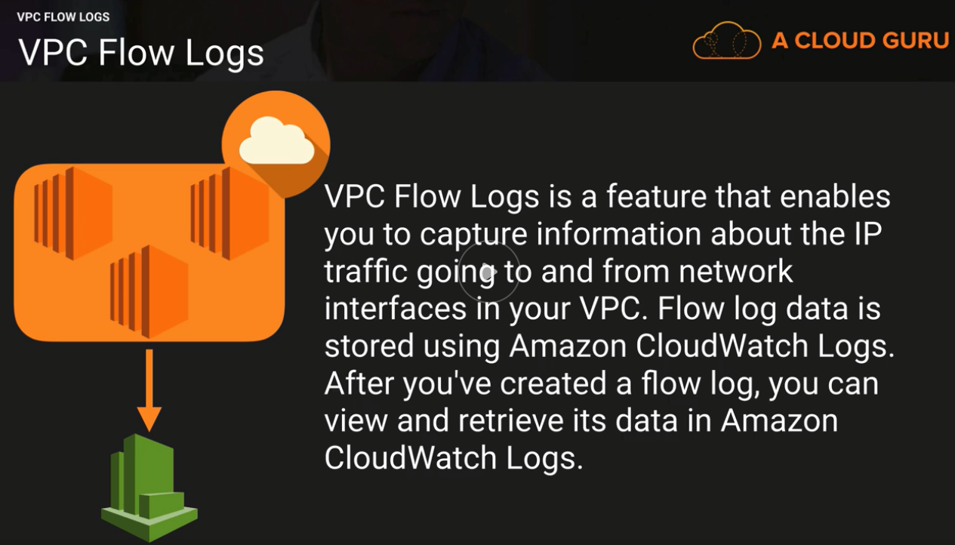

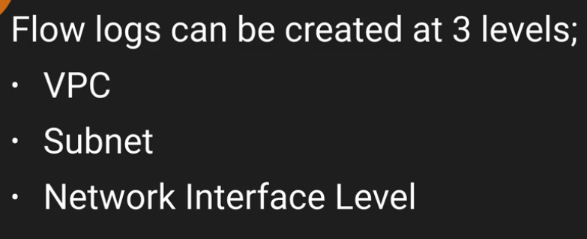

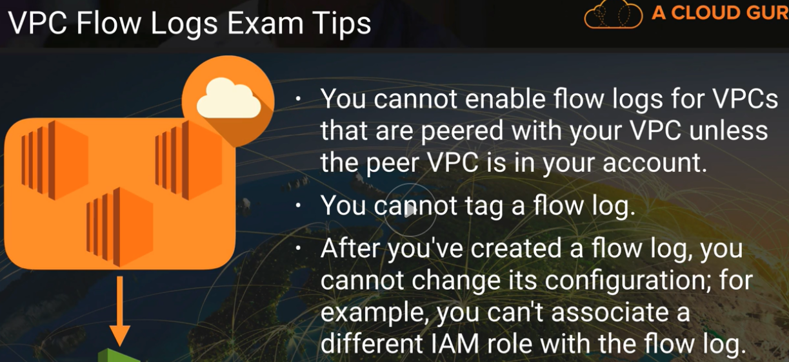

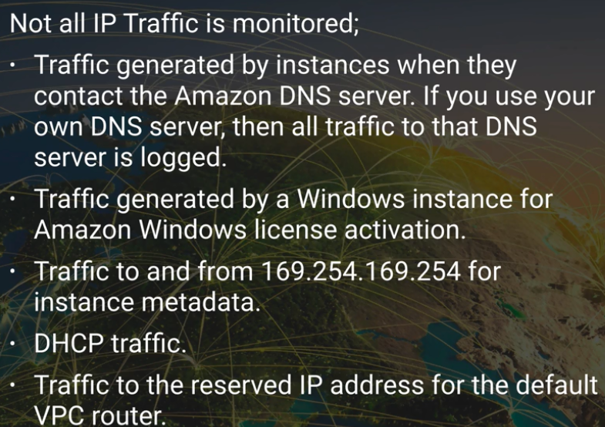

**NAT v/s Bastion**

**Bastion (jump box) – VM in public network that has direct connectivity to VMs in private network**

**Your VM → Ssh → Bastion → SSH ➔ VMs in private network in AWS cloud..**

**High resilency Bastion network..- failover handling…**

-          **Auto.--> New VM Bastion should be created in another availability zone..**

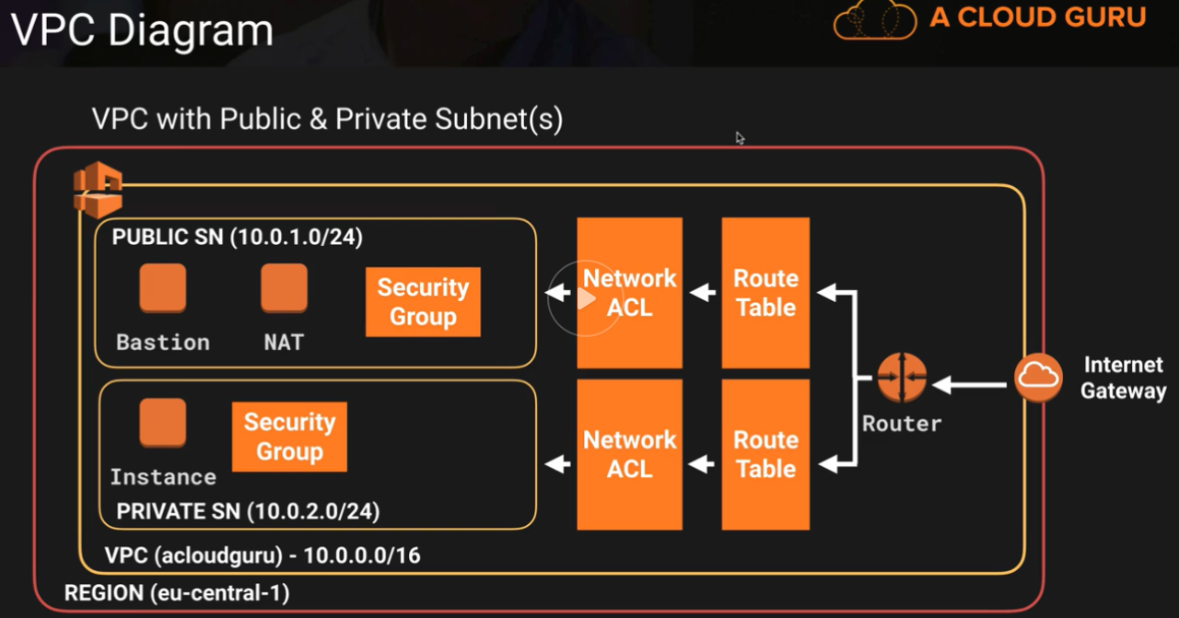

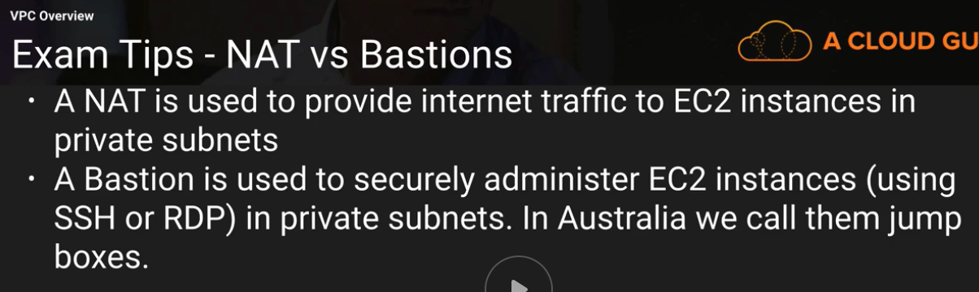

**NACL**

A network ACL is a numbered list of rules that AWS evaluates in order, starting with the lowest numbered rule, to determine whether traffic is allowed in or out of any subnet associated with the network ACL

default network ACL associated with every subnet that allows all inbound and outbound traffic.

custom network ACL, its initial configuration will deny all inbound and outbound traffic until you create rules that allow otherwise

every subnet must be associated with a network ACL

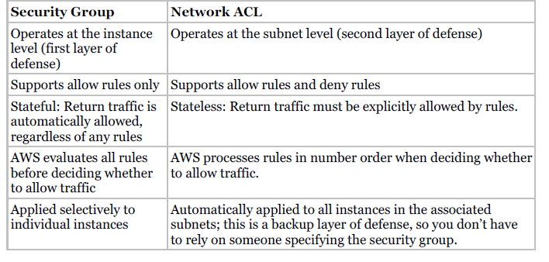

**Network Address Translation (NAT) Instances and NAT Gateways**

The NAT gateway provides better availability and higher bandwidth, and requires less administrative effort than NAT instance

A *network address translation (NAT) instance*is an Amazon Linux Amazon Machine Image (AMI) that is designed to accept traffic from instances within a private subnet, translate the source IP address to the public IP address of the NAT instance, and forward the traffic to the IGW

**Stateful**

amzn-ami-vpc-nat in their names

To allow instances within a private subnet to access Internet resources through the IGW via a NAT instance, you must do the following:

Create a security group for the NAT with outbound rules that specify the needed Internet resources by port, protocol, and IP address.

Launch an Amazon Linux NAT AMI as an instance in a public subnet and associate it with the NAT security group.

Disable the Source/Destination Check attribute of the NAT.

Configure the route table associated with a private subnet to direct Internet-bound traffic to the NAT instance (for example, i-1a2b3c4d).

Allocate an EIP and associate it with the NAT instance.

**NAT Gateway**

A *NAT gateway*is an Amazon managed resource that is designed to operate just like a NAT instance, but it is simpler to manage and highly available within an Availability Zone.

To allow instances within a private subnet to access Internet resources through the IGW via a NAT gateway, you must do the following:

Configure the route table associated with the private subnet to direct Internetbound traffic to the NAT gateway (for example, nat-1a2b3c4d).

Allocate an EIP and associate it with the NAT gateway.

To create an Availability Zone-independent architecture, create a NAT gateway in each Availability Zone and configure your routing to ensure that resources use the NAT gateway in the same Availability Zone.

Egress-Only Internet Gateways

An egress-only Internet gateway is a horizontally scaled, redundant, and highly available VPC component that allows outbound communication over IPv6 from instances in your VPC to the Internet, and prevents the Internet from initiating an IPv6 connection with your instances.

**Note**

An egress-only Internet gateway is for use with IPv6 traffic only. To enable outbound-only Internet communication over IPv4, use a NAT gateway instead.

**Virtual Private Gateways (VPGs), Customer Gateways (CGWs), and Virtual Private Networks (VPNs)**

You can connect an existing data center to Amazon VPC using either hardware or software VPN connections, which will make Amazon VPC an extension of the data center. Amazon VPC offers two ways to connect a corporate network to a VPC: VPG and CGW.

A *virtual private gateway (VPG)*is the *virtual private network (VPN)*concentrator on the AWS side of the VPN connection between the two networks.

A *customer gateway* *(CGW)*represents a physical device or a software application on the customer’s side of the VPN connection. After these two elements of an Amazon VPC have been created, the last step is to create a VPN tunnel.

The VPN tunnel is established after traffic is generated from the customer’s side of the VPN connection

If the CGW supports Border Gateway Protocol (BGP), then configure the VPN connection for dynamic routing. Otherwise, configure the connections for static routing. If you will be using static routing, you must enter the routes for your network that should be communicated to the VPG. Routes will be propagated to the Amazon VPC to allow your resources to route network traffic back to the corporate network through the VGW and

across the VPN tunnel.

Amazon VPC also supports multiple CGWs, each having a VPN connection to a single VPG (many-to-one design). In order to support this topology, the CGW IP addresses must be unique within the region.

The VPG is the AWS end of the VPN tunnel.

The CGW is a hardware or software application on the customer’s side of the VPN tunnel.

You must initiate the VPN tunnel from the CGW to the VPG.

VPGs support both dynamic routing with BGP and static routing.

The VPN connection consists of two tunnels for higher availability to the VPC.

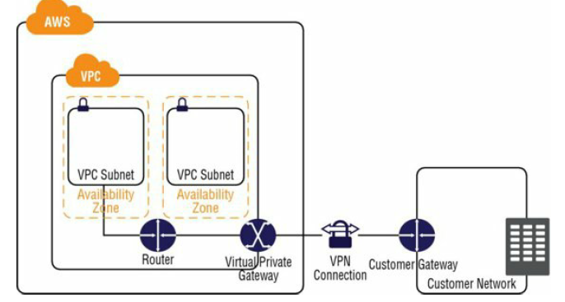

**Security Group**

virtual stateful firewall that controls inbound and outbound network traffic to AWS resources and Amazon EC2 instances

**Every EC2 instance needs to have a SG -Mandatory**

The default security group allows communication between all resources within the security group, allows all outbound traffic, and denies all other traffic

**Default SG – can be changed but not deleted**

**Exam:**

You can create up to 500 security groups for each Amazon VPC.

You can add up to 50 inbound and 50 outbound rules to each security group.

If you need to apply more than 100 rules to an instance, you can associate up to five security groups with each network interface.

You can specify allow rules, but not deny rules. This is an important difference between security groups and ACLs.

You can specify separate rules for inbound and outbound traffic.

By default, no inbound traffic is allowed until you add inbound rules to the security group.

By default, new security groups have an outbound rule that allows all outbound traffic. You can remove the rule and add outbound rules that allow specific

outbound traffic only.

Security groups are stateful. This means that responses to allowed inbound traffic are allowed to flow outbound regardless of outbound rules and vice versa. This is an important difference between security groups and network ACLs.

Instances associated with the same security group can’t talk to each other unless you add rules allowing it (with the exception being the default security group).

You can change the security groups with which an instance is associated after launch, and the changes will take effect immediately

**VPC endpoint**

**VM in private network wants to send data to AWS S3, instead of going though NAT gateway though pubic APIS,**

-          **It can be done internally.**

VPC *endpoint*enables you to create a private connection between your Amazon VPC and another AWS service without requiring access over the Internet or through a NAT instance, VPN connection, or AWS Direct Connect

You can create multiple endpoints for a single service, and you can use different route tables to enforcedifferent access policies from different subnets to the same service

The routing table

**Destination Target**

[10.0.0.0/16](https://urldefense.proofpoint.com/v2/url?u=http-3A__10.0.0.0_16&d=DwQFAg&c=j-EkbjBYwkAB4f8ZbVn1Fw&r=e6HgaTz-VmlyFzQ6g-ctUAxWf7XUSNXlQ5y-qpblsjA&m=XfaPU__el0Xyah6EN7I0EEOJWre3PC1LZWIr3r-C6G8&s=d3BFtwZAwVT8AnkilgxMVvuepDzrVg51ZQhPR2dR2BQ&e=) Local

[0.0.0.0/0](https://urldefense.proofpoint.com/v2/url?u=http-3A__0.0.0.0_0&d=DwQFAg&c=j-EkbjBYwkAB4f8ZbVn1Fw&r=e6HgaTz-VmlyFzQ6g-ctUAxWf7XUSNXlQ5y-qpblsjA&m=XfaPU__el0Xyah6EN7I0EEOJWre3PC1LZWIr3r-C6G8&s=9rhUDwR0WoHfX3eNuuHy9bHE1wiEx0oeieH_MPKDHmg&e=) igw-1a2b3c4d   -- Internet connection will use this route + S3 traffic outside of region + Other AWS services..

pl-1a2b3c4d vpce-11bb22cc – for S3 traffic within region,

**Create a role that provides S3 access, assign to EC2 instance**

**Update route → remote public access –**[**0.0.0.0**](https://urldefense.proofpoint.com/v2/url?u=http-3A__0.0.0.0&d=DwQFAg&c=j-EkbjBYwkAB4f8ZbVn1Fw&r=e6HgaTz-VmlyFzQ6g-ctUAxWf7XUSNXlQ5y-qpblsjA&m=XfaPU__el0Xyah6EN7I0EEOJWre3PC1LZWIr3r-C6G8&s=HXKES-04e2OFDzI-1FhN-nCwwjoD8H0y0I6iGxOIzTU&e=)**./0**

**Add VPC endpoint,  -- Select S3 gateway → select VPC → select main route table..**

**Verify VPC**

**From prinate VM – run command aws s3 ls..**

**Will work without NAT gateway**

**Working using private network,, not public..**

**VPC n**

**Elastic IP address (EIPs)**

An *Elastic IP Addresses (EIP)*is a static, public IP address in the pool for the region that you can allocate to your account

**AWS maintain a pool of IP address for each region**

**Reserve and release IP address.**

**Import for exam :**

You must first allocate an EIP for use within a VPC and then assign it to an Instance

EIPs are specific to a region (that is, an EIP in one region cannot be assigned to an instance within an Amazon VPC in a different region).

There is a one-to-one relationship between network interfaces and EIPs.

You can move EIPs from one instance to another, either in the same Amazon VPC or a different Amazon VPC within the same region.

EIPs remain associated with your AWS account until you explicitly release them.

There are charges for EIPs allocated to your account, even when they are not associated with a resource.

**Elastic Network Interfaces (ENIs)**

a virtual network interface that you can attach to an instance in an Amazon VPC

only available within an Amazon VPC, and they are associated with a subnet upon creation

They can have one public IP address and multiple private IP addresses. If there are multiple private IP addresses, one of them is primary

Assigning a second network interface to an instance via an ENI allows it to be dual-homed (have network presence in different subnets)

An ENI created independently of a particular instance persists regardless of the lifetime of any instance to which it is attached; if an underlying instance fails, the IP address may be preserved by attaching the ENI to a replacement instance.

Usecases

-          create a management network,

-          use network and security appliances in your Amazon VPC,

-          create dual-homed instances with workloads/roles on distinct subnets,

-          Create a low-budget, high-availability solution

An elastic network interface (referred to as a *network interface* in this documentation) is a virtual network interface that can include the following attributes:

* a primary private IPv4 address
* one or more secondary private IPv4 addresses
* one Elastic IP address per private IPv4 address
* one public IPv4 address, which can be auto-assigned to the network interface for eth0 when you launch an instance
* one or more IPv6 addresses
* one or more security groups
* a MAC address
* a source/destination check flag
* a description

You can create a network interface, attach it to an instance, detach it from an instance, and attach it to another instance.

A network interface's attributes follow it as it is attached or detached from an instance and reattached to another instance. When you move a network interface from one instance to another, network traffic is redirected to the new instance.

default network interface – cannot be detached